CHC62015M Advanced Diploma of Community Sector Management
Release 2

CHC62015M Advanced Diploma of Community Sector Management

Modification History

Release | Comments
Release 1 | This version released with CHC Community Services Training Package Version 11.  CHC62015M Advanced Diploma of Community Sector Management supersedes and is not equivalent to CHC62015 Advanced Diploma of Community Sector Management.  Major changes to core and elective units of competency.

Qualification code  DRAFT  Mandatory field | CHC62015M
Qualification title  Mandatory field | Advanced Diploma of Community Sector Management
Qualification description  Mandatory field | This qualification reflects the role of workers who are middle managers or managers across a range of community sector organisations. These people work independently and report to executive management, directors or boards of management. They undertake a range of functions requiring the application of knowledge and skills to achieve results in line with the organisation's goals and strategic directions.  At this level, workers have responsibility for planning and monitoring service delivery, recruitment and performance management of other paid or unpaid workers, managing risk and contributing to continuous improvement within the scope of their specific role. This may include management of a specific program or project, or broader management of community services organisations such as a community-based organisation, early childhood education service, not-for-profit organisation or community centre.  The skills in this qualification must be applied in accordance with Commonwealth and State or Territory legislation, Australian standards and industry codes of practice.
Foundation skills outcomes  Mandatory field | The foundation skills outcomes implicit in this qualification are outlined in the below bar chart.  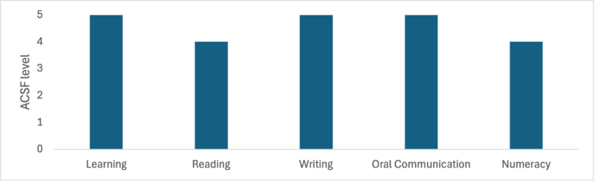  Note: Some elective units require higher foundation skills levels. Please refer to the Companion Volume Implementation Guide for more information.
Entry requirements  DRAFT  Optional field | Entry to this qualification is open to individuals who can demonstrate foundational community services competence through:  - a qualification at Certificate IV level or higher in community services; or  - evidence of at least 12 months of work (paid or volunteer) in community services role(s)
Qualification mapping information  Mandatory field | CHC62015M Advanced Diploma of Community Sector Management supersedes and is not equivalent to CHC62015 Advanced Diploma of Community Sector Management.
Packaging Rules | Total number of units = 13  - 9 core units  - 4 elective units, consisting of:  - at least 2 units from the electives listed below  - up to 2 units from any endorsed Training Package or accredited course – these units must be relevant to the work outcome  All electives chosen must contribute to a valid, industry-supported vocational outcome.  *proposed draft title – subject to consultation  M indicates proposed major changes  X indicates cross sector  Core units  Elective units
  BSBFIN601 | Manage organisational finances
  BSBLDR601 | Lead and manage organisational change
  BSBOPS504 | Manage business risk
  BSBPEF401 | Manage personal health and wellbeing
  BSBSTR601 | Manage innovation and continuous improvement
  CHCDIV003M | Manage and promote diversity
  CHCLEG003M | Manage legal and ethical compliance
  CHCMGT001M | *Develop, implement and review quality systems
  CHCMGT003 | Lead the work team
  BSBHRM521 | Facilitate performance development processes
  BSBHRM531 | Coordinate health and wellness programs
  BSBHRM614 | Contribute to strategic workforce planning
  BSBINS601 | Manage knowledge and information
  BSBLDR602 | Provide leadership across the organisation
  BSBMKG542 | Establish and monitor the marketing mix
  BSBMKG623 | Develop marketing plans
  BSBOPS601 | Develop and implement business plans
  BSBPMG530 | Manage project scope
  BSBPMG540 | Manage project integration
  BSBSTR503 | Develop organisational policy
  BSBSTR602 | Develop organisational strategies
  BSBSTR603 | Develop business continuity plans
  BSBSUS511 | Develop workplace policies and procedures for sustainability
  BSBWHS512 | Contribute to managing work-related psychological health and safety
  BSBWHS603 | Implement WHS risk management
  CHCADV004 | Represent organisation in court or tribunal
  CHCADV005 | Provide systems advocacy services
  CHCCCS007 | Develop and implement service programs
  CHCCDE028M | Work within organisation and government structures to enable community development outcomes
  CHCCDE029 | Establish and develop community organisations or social enterprise
  CHCCOM003M | Develop workplace communication strategies
  CHCCSM012 | Coordinate complex case requirements
  CHCCSM014M | Provide case management supervision
  CHCDIV002M | *Support culturally responsive practices with Aboriginal and/or Torres Strait Islander peoples
  CHCECE051 | Promote equity in access to the service
  CHCECE052 | Plan service and supports for children and families
  CHCECE053 | Respond to grievances and complaints about the service
  CHCFAM003 | Support people to improve relationships
  CHCFAM009 | Facilitate family intervention strategies
  CHCMGT002 | Manage partnership agreements with service providers
  CHCMGT004 | Secure and manage funding
  CHCMGT005 | Facilitate workplace debriefing and support processes
  CHCMGT006 | Coordinate client directed services
  CHCMGT007 | Work effectively with the Board of an organisation
  CHCMHS010 | Implement recovery-oriented approaches to complexity
  CHCPOL003 | Research and apply evidence to practice
  CHCPRP003 | Reflect on and improve own professional practice
  CHCPRP004 | Promote and represent the service
  CHCPWK006 | Promote and conduct mental health peer work
  CHCVOL003 | Recruit, induct and support volunteers
  CHCVOL004 | Manage volunteer workforce development
  FNSACC634 | Monitor corporate governance activities
  PSPGEN125 | Support workplace coaching and mentoring
  PSPLAN003 | Source information on Deaf culture, and communicate according to Deaf protocol
  PUAEMR035 | Facilitate community involvement in recovery
  TAEDEL414 | Mentor in the workplace

